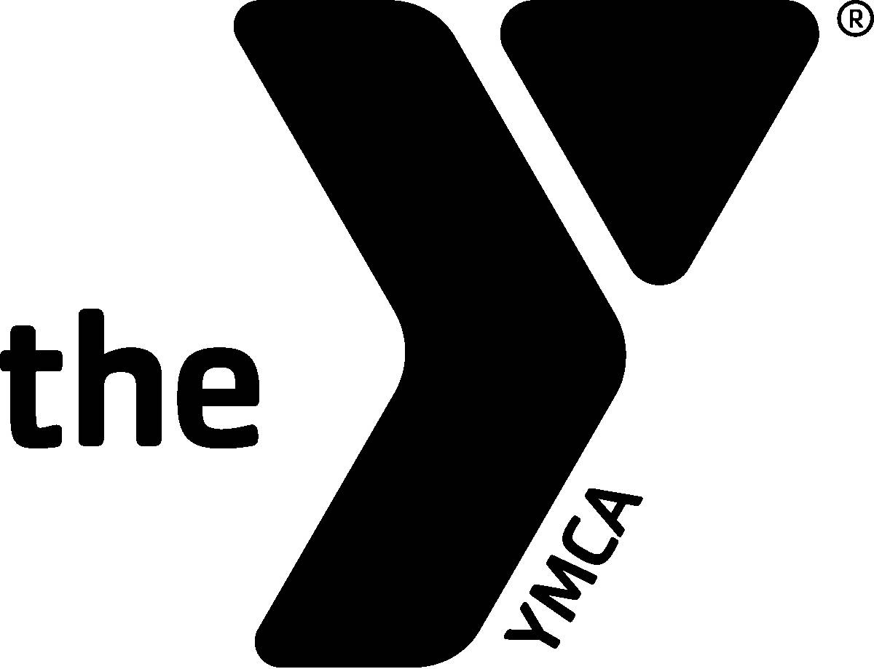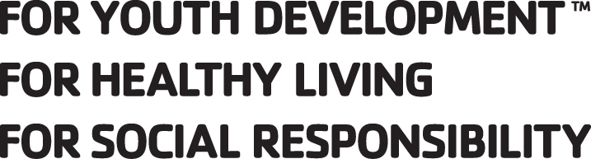

Northern Lights YMCA
Swim Team Handbook
2024-2025 Season

Delta Aquatic Center
2001 North Lincoln Road
Escanaba, MI 49829
Phone: 906.789.0005 Fax: 906.789.6330

Dickinson Program Center
800 Crystal Lake Blvd.
Iron Mountain, MI 49801
Phone: 906.777.4076 Fax: 906.774.4979

Northern Lights YMCA Swim Team
WELCOME

ABOUT THE TEAM
The Northern Lights YMCA Swim Team is a competitive swim program serving youth swimmers in the Delta and Dickinson County communities.

MISSION
The Northern Lights YMCA Swim Team is committed to providing an enjoyable swimming experience for swimmers of all abilities. We strive on teaching and improving technique in strokes to achieve personal best. Our goal is to build sportsmanship, character, skills, friendships and health in our swimmers everyday lives.

ORGANIZATION / STAFF
The Head Swim Coach is responsible for all administrative aspects of the Northern Lights YMCA Swim Team including program operation, supervision of assistant coaching personnel, volunteers and parent coordination.

The Head Coach, along with assistant coaches, is responsible for coordinating meets, practice sessions and preparing your swimmer for competition at the appropriate level.

NLY Head Coach Delta Center: Karin Lanaville- kromin_lanaville@hotmail.com or 906-789-0005
Head Coach Dickinson Center: Aimee Tatangelo- actatangelo@gmail.com or 906-774-4076

PRACTICE INFORMATION

PRACTICE GROUPS
The NLY Swim Team participants are divided into three practice groups based on skill – Beginners, Intermediate, and Advanced. Practice groups are determined by the coaching team. Swimmers will be assigned by the head / assistant coach to a practice group with others of similar ability. Workouts are adjusted according to the experience and skill.

GROUP SWIM TEAM PRACTICES
Beginners: This group is geared for swimmers who are new to competitive swimming. Practice time is devoted to the teaching of the four competitive strokes - Freestyle, Backstroke, Breaststroke and Butterfly - and fundamental swimming skills such as starts and turns. Swimmers will also be introduced to endurance training. Beginners are welcomed to participate in Swim Meets, but swim meet participation is not required.

Intermediate: This group will continue to learn techniques for the four competitive strokes, along with starts and turns for the four competitive strokes. Practice will also be devoted to endurance training and learning the strategies of racing. Swim meet participation is recommended, but not required.

Advanced: This group has competitive swimming experience. Practice time will be devoted to endurance training, continual teaching of the four competitive strokes - Freestyle, Backstroke, Breaststroke, and Butterfly - and fundamental swimming skills such as starts and turns. Swim meet participation is recommended, but not required.

*All swimmers are members of the YMCA and can swim during regular scheduled open or lap swim times. It is recommended for the Intermediate and Advanced groups to swim at least once a week during open or lap times. Sample workouts will be available in the pool office.

PRACTICE TIMES / DAYS
DELTA PROGRAM CENTER:
Beginners: Tuesday, Thursday, & Friday 4:30 – 5:30 PM
Intermediate: Tuesday, Thursday & Friday 4:30 – 6:30 PM
Advanced: Tuesday, Thursday, & Friday 4:30 – 6:30 PM

DICKINSON PROGRAM CENTER:
Beginners: Monday and Wednesday 4:45 – 5:30 PM
Intermediate: Monday, Wednesday, Thursday 5:00 – 6:15 PM
Advanced: Monday, Wednesday, Thursday 5:00 – 6:305PM
** Please note that this times will change mid Nov. You will be notified of the new times closer to the change.

COMPETITION
Swimming meets are the pay-off for the hours of training. Competing in swim meets, swimming a new event successfully, improving times, meeting new friends, earning ribbons and/or medals, and increasing self-esteem are things that motivate swimmers in practice. In most cases, meets are selected to include a maximum number of our team.

We are a dual branch team combining swimmers from Delta County (Escanaba) and Dickinson County (Iron Mountain) branches. At meets, both branches will swim for the NLY Swim Team. Relay teams will be combined with swimmers from both branches.

MEET INFORMATION / SWIM MEET FACTS:
Age Groups for Competition
Swimmers are divided into different age groups for competition purposes. Age grouping combinations may differ at various meets. During the fall/winter season, the age of the swimmer is determined by how old he/she is on December 1 for the YMCA meets. However, some meets may have the swimmers age as of the day of the meet.

EVENTS:
Freestyle: In the freestyle, the competitor may swim any stroke he/she wishes. The usual stroke is the front crawl. This stroke is characterized by alternate overhand motion of arms. The distances are 25 yards, 50 yards, 100 yards, 200 yards, 500 yards, 1000 yards and 1650 yards.

Backstroke: In the backstroke, the swimmer is on his/her back. The stroke is alternating motion of the arms. The distances are 25 yards, 50 yards, 100 yards, and 200 yards.

Breaststroke: The breaststroke requires simultaneous movements of the arms on the same horizontal plane. The hands are pushed forward from the breast under the surface of the water and brought backwards together. The breast kick is simultaneous thrust of the legs. No flutter kick is allowed. On the turns and finishes the swimmer must touch with both hands at the same time in the same plane. The distances are 25 yards, 50 yards, 100 yards and 200 yards.

Butterfly: The butterfly stroke features the simultaneous overhand stroke of the arms combined with the dolphin kick. In the dolphin kick the swimmer must kick with both legs together and may not flutter kick as on freestyle. On the turns and finishes the swimmer must touch with both hands at the same time. The distances are 25 yards, 50 yards, 100 yards and 200 yards.

Individual Medley: The individual medley - or IM - features all four strokes. In the IM, the swimmer begins with the butterfly, changes after 1/4 of the race to backstroke, changes again after another 1/4 to the breaststroke and finishes with the final 1/4 in front crawl. The distances are 100 yards, 200 yards and 400 yards.

Medley Relay: In the medley relay, all four strokes are swum by four different individuals. The order of the medley relay is backstroke, breaststroke, butterfly and front crawl. The distances are 100 yards, 200 yards and 400 yards.

Freestyle Relay: In these relays, four swimmers swim freestyle for the entire relay. The distances are 100 yards, 200 yards, 400 yards and 800 yards.

MEET ENTRIES
All entries to attend meets will be done through TEAM UNIFY. Account information will be emailed to you upon completion of your handbook paperwork. All swimmers MUST have an account to take part in any and all swim meets. Signing up for swim meets is time sensitive! Entering swim meets is the responsibility of the parent of the swimmer. Late entries will not be accepted!
Swimmers can pick their events should they like. If left blank, the coaches will pick the events on their behalf. The coaching staff reserves the right to change swimmers events. Parents will receive a confirmation of events from the coach through Team Unify. You must indicate in Team Unify if you are committing to attend a meet or NOT. All swimmers who enter a swim meet will be considered for relays and expected to participate in relays if assigned by the coaching staff. All completed entries are available to be viewed on Team Unify. Swimmers must have a method of payment on file at the front desk. Once a swimmer is entered in a swim meet, the entry fees will be charged to the account prior to the meet. Entry fees are not refundable. If a swimmer does not attend a meet they will be responsible to pay for the events they are entered in and all fees of any relays that may be scratched.

RELAY POLICIES
Relays for all meets are determined by the Head / Lead Coach and coaching staff. There is no established rule for setting up relays at regular meets. Relay teams will be with the Escanaba and Iron Mountain swimmers combined. At States the "A" Relay will generally be the fastest four swimmers, as determined by the coaches.

TRANSPORTATION
Bad weather is a concern to parents. The decision to travel or to pull off the road is that of the parents. No meet is worth the risk of an accident.

If traveling to a meet, the swimmers must be on site and ready for warm-up time. The warm-up before a meet is VERY IMPORTANT to the swimmers and the team. Swimmers need to check out the starting blocks, practice turns and condition muscles before the competition. This also allows the coaches to take attendance and make adjustments to relays if needed.

TEAM EXPECTATIONS

INFORMATION FOR SWIMMERS
You are representing our team and the YMCA at all times. Please show proper respect for yourselves and for others with your actions and words.

Come to practices dressed for the weather. Be dry and dressed warmly before leaving the YMCA. Remember, your success is dependent on your health.

Always be on time for practice and meets.

Always use a lock on your locker to keep your belongings safe. Lockers can be rented at the front desk if available.

If you have any questions or difficulties, always consult with your coach.

DISCIPLINE
Discipline on the team shall be such that the safety and well-being of the individuals and the team are not jeopardized. Discipline problems will be handled between the athlete, the coach, the parents or guardians, and the YMCA administration if deemed necessary including warnings, suspensions and expulsions.

ATTENDANCE
Athletes improve their skills and endurance by practicing and competing. While swimmers attendance at practice is not required, it is encouraged, and expected, that swimmers make as many practices as possible.

Attendance at swim meets is not required. However, it is encouraged, that swimmers attend as many meets as possible.

If a swimmer cannot make a practice, please text or email Coach Karin Lanaville or Coach Aimee Tatangelo to let them know.

TEAM SUITS
Swim suits are not included in the program or membership fees. While competing, the specified team suit must be worn. This is to show team spirit and unity at meets. You can purchase the required team suit – TYR Tyreco in the color Peacock – from swimoutlet.com or also on amazon.com and other online sites. It is recommended that the team suits purchased for meets be worn to swim meets only. Additional practice suits are highly suggested.

TEAM SWIM CAPS
A latex team swim cap will be provided to each swimmer. It is a requirement for all swimmers to wear a NLY swim cap while participating at meets. Additional team swim caps including silicone caps may be purchased from the from the YMCA front desk. The coaching staff will also have extras if needed during swim meets.

WHAT TO TAKE AND EXPECT FOR A SWIM MEET
See the “Swim Meet Checklist” and “Swim Meet 101” handout at the back of the handbook.

If you are scheduled for a meet and are unable to attend, please call the head coach. Remember that any relays scratched by your absence will be billed to your account. We will try to fill the relays with other swimmers.

USA SWIMMING RULE
Northern Lights YMCA swimmers can swim USA Swimming only as an unattached swimmer (see “dual representation” in USA swimming hand book and YMCA swimming hand book). NLY swimmers can compete in USA swim meets as long as they do not conflict with NLYMCA swim team meets. Northern Lights YMCA coaches will not be responsible for swim entries for USA swim meets. Times from USA meets may be applied to a YMCA swimmers time data base when swimming during the NLY swim season. Times will not be entered if the meet is out of season (Sept. 16, 2025-March 22, 2026). Swimmers must send via email the results PDF file to the coach within 2 days of the USA swim meet. No times will be applied if a USA swim meet coincides with a YMCA scheduled meet. This rule does not apply for the USA state meet.

NLYMCA state/national relays and USA swimming – All swimmers are eligible for relays. However when considering relays a swimmer must swim a majority of their meets NLYMCA over USA. This means that at least 2/3 or 66% of meets competed in must be with the NLYMCA team schedule to be considered for state/national relay teams.

STATE "Y" MEET QUALIFICATION
The big meet of the fall/winter season is the YMCA State Championships, usually held at the end of March. To qualify for this meet, a swimmer must equal or beat a qualifying time during the current swim year. In addition, a swimmer must swim in one “YMCA Closed” meet during the current swim year. Those who do not intend to swim in the YMCA State Meet should notify the coach prior to the State Meet. The coach will determine all relays for the State Meet. Swimmers must be members of the team they will represent at least 90 days prior to the state meet. In addition, all fees must be paid in full. These qualifications are subject to change if changed by the governing body.

NATIONAL QUALIFICATION
There are two YMCA National meets held during the year. The Spring Nationals will be held in Greensboro, North Carolina or in Orlando, Fl in the beginning of April. The Summer Nationals are held in Greensboro, North Carolina the last week of July. National Meet swimmers must equal or beat National qualifying times or make a relay team that has made a qualifying time. In addition, swimmers who want to attend nationals must swim in 3 closed inter-association meets (meets with only YMCA teams) plus one sanctioned meet. The State meet is a sanctioned meet. All swimmers who attend National meets must be YMCA members. Swimmers must be members of the Y team they will represent at least 90 days prior to National meets. In additional, all fees must be paid in full.

HIGH SCHOOL – NLY SWIMMERS
All NLY swimmers that will also participate on the Gladstone or Kingsford swim teams are able to swim 2 meets during the high school competitive season per MHSAA rules. If there is a NLY hosted meet during this time, the swimmer MUST participate in the NLY hosted meet as one of their 2 allowed meets.

TEAM EXPENSE

MEMBERSHIP OF YMCA
All NLY Swim Team members must be full members of the Northern Lights YMCA. These memberships vary from individual youth to family memberships. YMCA members are entitled to use the building facilities during regular business hours. Facilities in Delta County include the pool, hot tub, sauna, fitness center, gymnasium, climbing wall and some classes. Discounts on other classes are also offered to full members. Facilities in Dickinson County include pool, sauna, fitness center, racquetball courts, group exercise studio and gymnasium. Discounts on other classes are also offered to full members. Memberships may be paid on a monthly basis by bank draft program or annually in one lump sum. Scholarships are available for those who may need financial assistance. Forms are available at the front desk.

The diversity of programs available makes family memberships very popular. For more information, contact the Membership Director at the YMCA.

TEAM PROGRAM FEE
The program fee charged for the Northern Lights swim team will vary depending on the age group and program center. There is also a discounted fee for additional family members of 10% per swimmer. Fees are non-refundable and must be paid in full by December 31. Program fees paid in full are for the fall /winter season which runs from September thru March.

The Northern Lights YMCA does have scholarships available for those swimmers in need (need based on family income.) If a family is interested, applications are available online or at the front desk. Any swimmer applying for a scholarship must have this application turned in at the start of the practice season.

Swim team program fees are due at registration unless prior arrangements are made. All swimmers will receive informational paperwork. Informational paperwork will include a registration form, emergency medical release, media release, financial information and a code of conduct. All forms must be completed and returned to the coach by Wednesday, October 1, 2025.

If the terms of this agreement are not met, a swimmer will not be allowed to practice with the team or enter meets. Or, if a family has unpaid meet fees (from two meets), the swimmer(s) will not be entered in swim meets.
SWIM SUITS
Team swim suits are required for swim meet participation. They can be purchased at swimoutlet.com or on amazon.com or other online sites.. The NLY team suit is the TYR Tyreco Diamondfit One Piece for femals and the TYR Tyreco Jammer for males, both in the color Peacock. The typical price for a swim suit ranges from $35 for jammers and $70 for full suits. If a swimmer is of age to wear a tech suit and chooses to, they may do so.

SWIM MEET FEES
These are the fees incurred when a swimmer signs up to participate in a meet. The cost to attend a meet ranges from $4 – 8 for individual events, $2 – 5 per person for a relay and some facilities have a splash fee that can range from $5-20.
Payment for meets will be charged prior to the meet. An account will be made for your swimmer(s) and a method of payment must be on file at the front desk. The account will be charged immediately when a swimmer signs up for a meet. There will be no refunds once swimmer is officially signed up for a meet.

If an account has a balance, that swimmer will be prohibited from swimming in any swim meet until the balance is paid in full, this includes balances from past seasons as well.

TRANSPORTATION
For out-of town meets, swimmers are responsible to make their own transportation & lodging arrangements.

PARENT ROLE

INFORMATION
Parents working together with coaches, officials and administrators, have a unique opportunity to influence the lives of young athletes. Positive support will help swimmers develop to their full potential while clarifying their personal values.
There are many ways to show this positive support. These include:
- Have swimmers at practice regularly and on time.
- Encourage children to get proper rest and develop good nutritional habits.
- Attend swim meet competitions regularly.
- Be informed by reading the handbook information sheets and the bulletin board in the pool area.
- Praise your swimmer and other team members.

Parents are the backbone of the swim team. Family Volunteer involvement is vital for a strong and effective team. A complete list of jobs will be available prior to home meets. Additionally we ask families to:
- Help support fundraisers. Remember a successful fundraiser helps keep program fees affordable.
- Work at home meets. To avoid paying staff to run a swim meet, every family is needed to work a minimum of a 4-6 hour shift! In addition, triple the event fees will be assessed to all swimmers in which a family is unable to volunteer at a home meet, this cost will range from $80 per swimmer and up per swimmer.
- Attend the annual parents meeting held at the beginning of the season.
- Be willing to donate items for concessions at the home meets.
- Enjoy the swim team season.

FUNDRAISING
Fundraising is a vital part of the success of the NLY Swim Team. The main fundraising for the team is the home swim meets which include concession donations. To keep fees affordable, it is important that ALL families take part in fundraising efforts.

SEASON END CELEBRATION
AWARDS NIGHT
After the conclusion of the Fall/Winter Season, there will be an Awards Night celebration (usually held in March or April). Location will be determined for each program center.

All NLY swimmers are recognized for their participation on the team. Special awards are also presented to the NLY swimmers. These awards can include: Most Inspirational, The Most Improved Award, High Points Award for each Gender in each age group, or the Biggest Loser Award for time dropped during swim season.

SOURCES OF INFORMATION
YMCA Website: www.nlymca.com or www.teamunify.com/Home.jsp?team=ymca-3012
Swimmer Folders: Located on Pool Deck During Practices (You will find Ribbons & Medals Here)
Email: Karin Lanaville (Delta) or Aimee Tatangelo (Dickinson)

Northern Lights YMCA Code of Conduct
The Northern Lights Swim Team promotes the following codes of conduct to all people involved in any way with the sport of swimming, particularly those responsible for activities involving members under the age of 18 years. These codes of conduct highlight the principles and values of the Northern Lights YMCA Swim Team and are the core principles of the Member Welfare and Child Welfare policies.
As a person involved in any way with the sport of swimming, the following standards of behavior are expected:
- Be aware of YMCA Swimming standards, rules and policies.
- Respect the rights, dignity and worth of others.
- Be professional in, and accept responsibility for your actions.
- Operate within the rules and spirit of the sport, including the national and international guidelines that govern YMCA Swimming.
- Any form of abuse, harassment, or discrimination towards others will not be tolerated.
- Provide a safe environment for the conduct of activities in accordance with any relevant NLY Swimming policy.
- Be a positive role model.

Parents Code of Conduct
As parents, it is absolutely essential that we give our coaching staff the respect and authority they deserve to run our swim team. Our coaches are hired for that purpose and the Head Coach oversees the direction of the staff. We expect our parents to demonstrate good sportsmanship during all practices, competitions and team activities. We expect our parents to promote good sportsmanship by setting an example and by helping others to do likewise. We expect our parents to celebrate wins gracefully, lose graciously, and congratulate opponents either way.
As a parent involved with the sport of swimming, the following standards of behavior are expected:
- Parents are asked to encourage your child to participate in the sport for their individual enjoyment, personal satisfaction and improvement.
- Parents are asked to focus on your child’s effort and performance, rather than winning or losing.
- Parents are asked to encourage your child to abide by the rules and accept judgements made by the officials.
- Parents are asked to never ridicule or yell at a child for making a mistake or performing below expectations.
- Parents are asked to be an example for your child and others. Appreciate good performances by all participants.
- Parents are asked to support all efforts to remove verbal and physical abuse from the sporting environment.
- Parents are asked to show appreciation and respect for all people involved in your child’s swimming.
- Parents are asked to respect the rights, dignity and worth of all participants, regardless of their gender, ability, ethnicity, cultural background or religion.

Swimmers Code of Conduct
As a member of the Northern Lights YMCA Swim Team, we believe in teamwork, integrity, respect and good sportsmanship.
Any athlete participating with/for the NLY Swim Team agrees to abide by the guidelines outlined below in addition to those established by the staff:

- Understand and follow the rules of YMCA Swimming at all times.
- Make every team practice, meet participation and activity an opportunity to learn.
- Swimmers are expected to remember that at practice, during swim meets, team activities, and in public they are representing the NLY Swim Team. They should represent NLY Swim Team with excellence, respect, team spirit, good sportsmanship and politeness.
- Swimmers are expected to follow directions and show respect, common courtesies and good sportsmanship at all times to the team members, coaches, staff, competitors, officials, parents and for all facilities and other property used during practices, competitions and team activities. Disrespect or failure to obey instructions will not be tolerated from any athlete.
- Swimmers should be punctual and arrive on time for all practices, meets and team events. Pool time is very valuable.
- Give your best at all times.
- Never argue with an official. Use the appropriate rules and guidelines to resolve a dispute.
- Control your temper. Verbal or physical abuse is not acceptable.
- Work equally hard for yourself and/or your team.
- Be a good sport. Applaud good performances whether they are made by your team or the opposition.
- Treat all swimming participants as you would like to be treated.
- Do not bully or take unfair advantage of another competitor.
- Cooperate with your coaches, teammates, opponents, management, event staff and officials.
- Participate for your own enjoyment and benefit, not to satisfy the expectations of others.
- Respect the rights, dignity and worth of all participants regardless of their gender, ability, ethnicity, cultural background or religion.
- Dishonesty, theft, or vandalism will not be tolerated.
- There shall be no drinking of alcohol, use of tobacco products, illegal drugs or any substances banned by YMCA Swimming.
- Swimmers are expected to respect each other. Fighting, bullying, intentional touching or striking another athlete will subject the swimmer to the most severe discipline.
- When wearing NLY branded garments, you are expected to represent yourself according to this Code of Conduct. You are an ambassador of the organization.

Violations
The Northern Lights YMCA Swim Team is a zero tolerance organization. The coaches and leadership staff have the authority to impose penalties for violation of the NLY Swim Team Code of Conduct.
Failure to uphold the Code of Conduct may result in:

Swimmer will be given a verbal warning.
Swimmer will need to be accompanied by a parent for practice for a time determined by the coach.
Swimmer will be suspended from practice for a time determined by the coach. (fees during this time will not be refunded)
Swimmer will be removed from the remainder of the NLY Swim Team season.
Swimmer will be permanently removed from the NLY Swim Team.

Northern Lights YMCA
Registration Form for 2025-2026 Season

Swimmer’s Name:____________________________________________________________________________________

Address:____________________________________________________________________________________________

City, State, Zip Code:__________________________________________________________________________________

Phone Number: _________________________________________________________________

Birthdate (Mo-Day-Year):__________________________ Age: ___________________________

Are you a NEW swim team member? Yes or No

---------------------------------------------------------------------------------------------------------------

Mother’s Name:______________________________________________________________________________________

Address:____________________________________________________________________________________________

City, State, Zip Code:__________________________________________________________________________________

Home Phone: _________________Work Phone: ________________ Cell Phone: _____________ Text Messages? Y N

Email: ______________________________________________________________________________________________

---------------------------------------------------------------------------------------------------------------

Father’s Name:_______________________________________________________________________________________

Address:____________________________________________________________________________________________

City, State, Zip Code:__________________________________________________________________________________

Home Phone: ______________ Work Phone: ______________ Cell Phone: ______________ Text Messages? Y N

Email: ______________________________________________________________________________________________

Please return the following forms to the front desk as soon as possible.

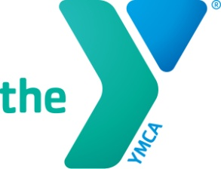
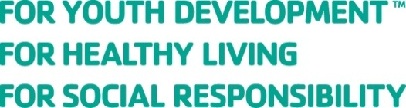

Emergency / Illness Information and Authorization Form
Season 2025-2026

Swimmer’s Name: _______________________________________________ Birth Date:__________________
Parents or Guardian:_____________________________________________________________________________
Phone Numbers (Home, Work, Cell):__________________________________________________________
Emergency Contact Other than Parent or Guardian:________________________________________________
Emergency Phone:________________________________________________________________________________
Primary Physician:_____________________________________________ Phone: ________________________
Dentist:______________________________________________________Phone:______________________________

Do any of the following conditions apply?
(If so, please explain and list necessary treatment / medications – dosage, time taken, etc.)

Heart / Lung / Vascular Impairment – Including Asthma:___________________________________________________________________________________________
Seizures:____________________________________________________________________________________________
Allergies – Including Medications:_______________________________________________________________________
___________________________________________________________________________________________________
Orthopedic Impairment:____________________________________________________________________________________
Injury History:____________________________________________________________________________________________
Other:______________________________________________________________________________________________
___________________________________________________________________________________________________
Insurance Provider and Numbers:_______________________________________________________________________

If the above child becomes ill or injured, I give permission to the Swim Team Coach, YMCA Staff or designed chaperone to have the child transported and receive medical treatment.

____________________________________________ _________________________________________
Parent or Guardian Date

Northern Lights YMCA
Financial Responsible Parent / Guardian Information

The parent / guardian listed below is financially responsible for the expenses incurred on behalf their swimmer during the 2024-25 NLY season. Expense may include: program fees, meet fees & extra swim caps.

Swimmer Name:_____________________________________________________________________________________

Financial Responsible Parent / Guardian: _______________________________________________________

Address:____________________________________________________________________________________________

City, State, Zip Code:__________________________________________________________________________________

Home Phone: _________________________________ Cell Phone: ______________________________________

Email: ____________________________________________________________________________________________________

Northern Lights YMCA
Release of Image for 2025-26 Season

I hereby give my permission for any photographs or video recording of my swimmer(s) participation in the Northern Lights YMCA / Gladstone High School Swim Team program to be used for publicity.

Swimmer(s) Name(s): ___________________________________________________________________________________________________

Parent / Guardian Signature: ___________________________________________________________________________________________________

